**High – Level System Overview.**

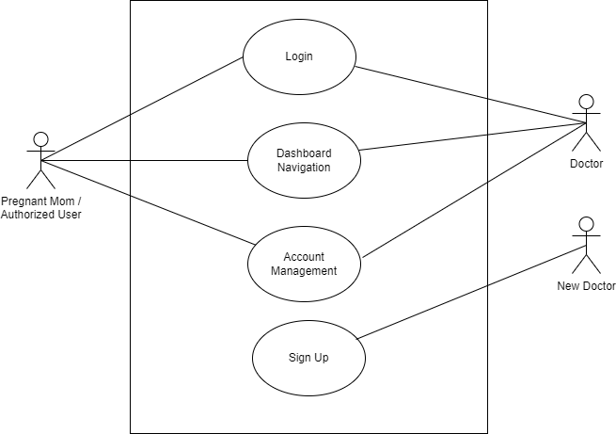

**Module Level Diagrams.**

1. Account Management Module.

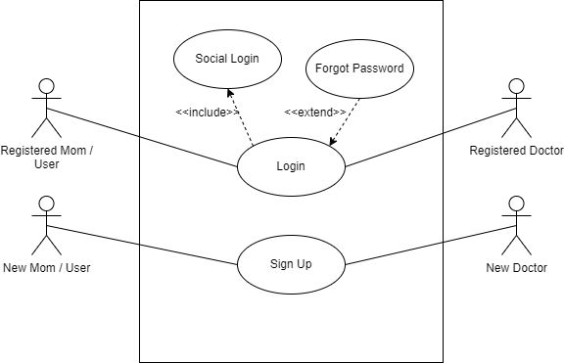

1. User Dashboard Module for Doctors.

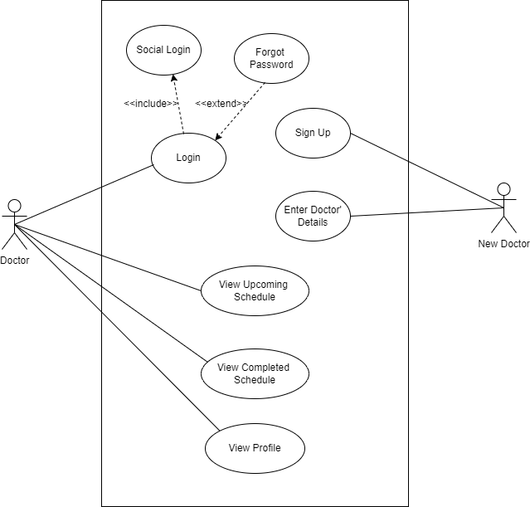

1. User Dashboard Module for Moms/ Authorized Users.

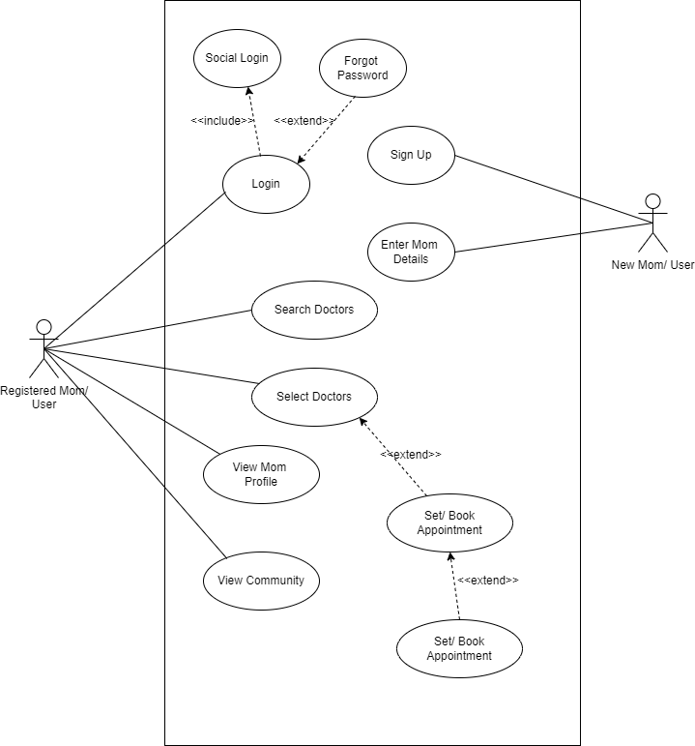

1. Mom Community Features Module.

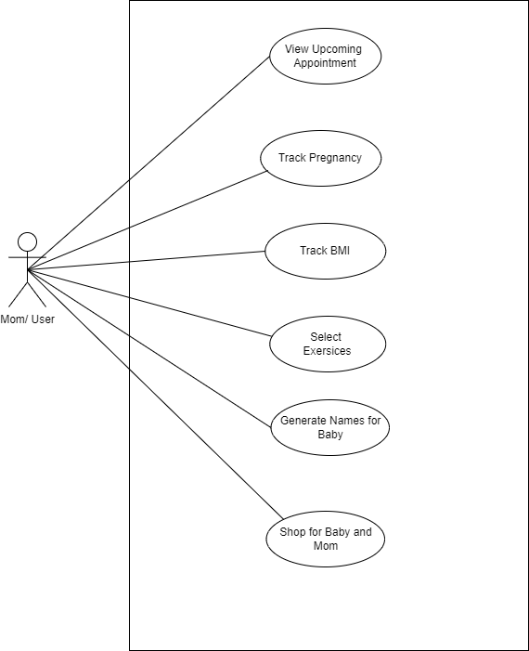

1. BMI Calculator Module.

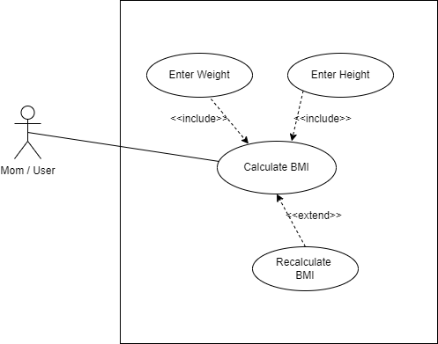

1. Name Generator for baby Module.

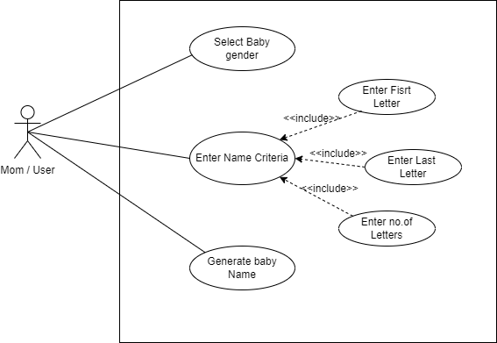

1. Exercises for Mom Module.

1. Sleep Tracking and analysis Module.

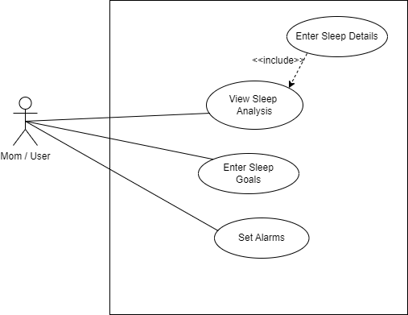

1. Shopping List Module.

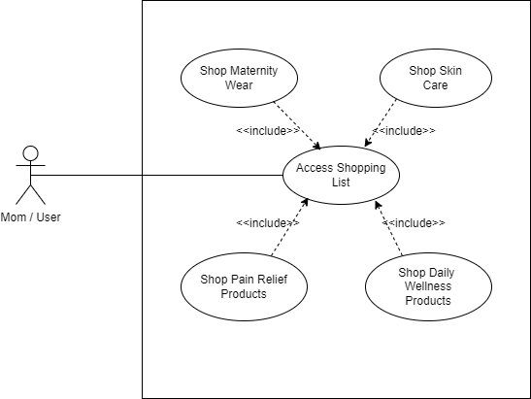

High – Level Activity Diagram.

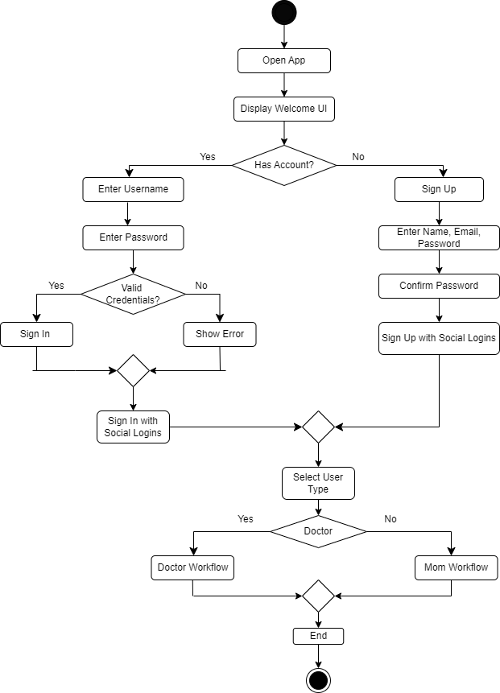

Mom Workflow.

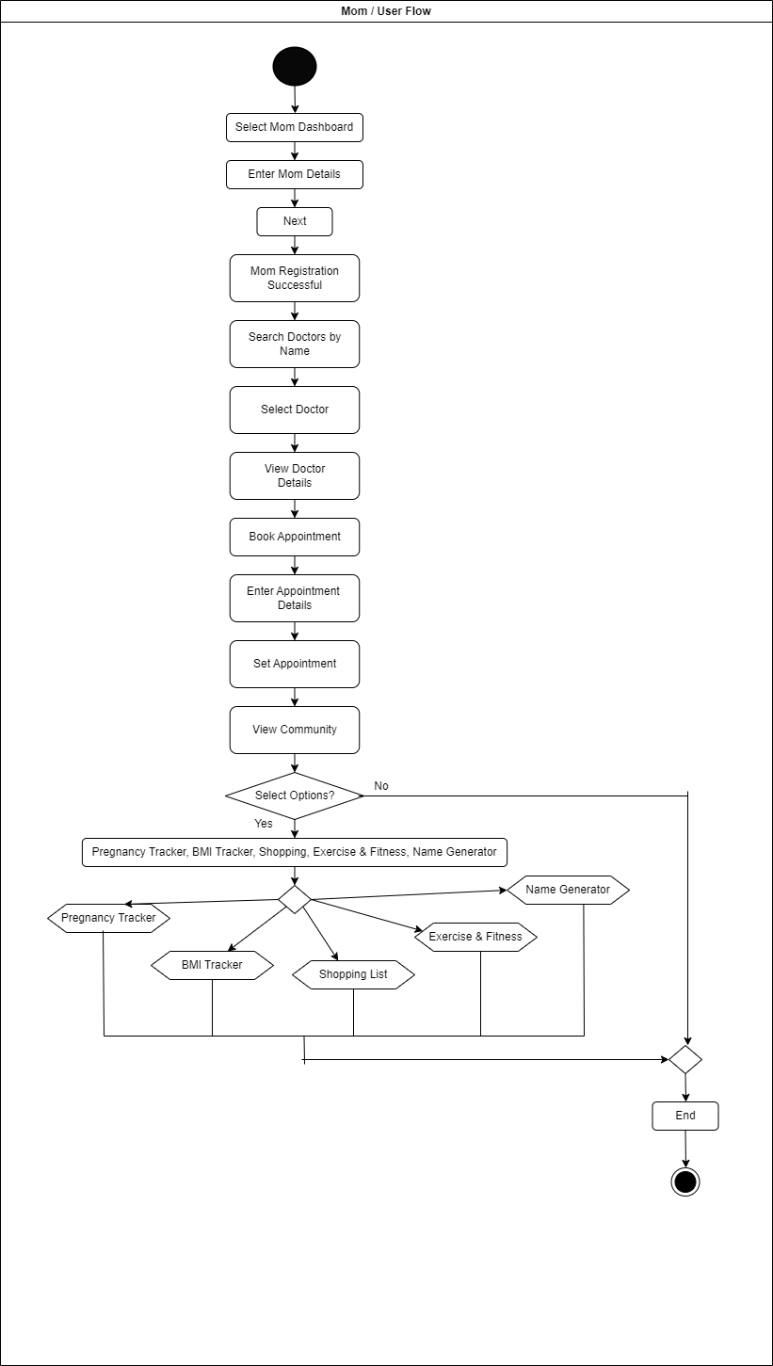

Doctor WorkFlow

